**MATH PROJECT REPORT 2018**

Joel Ala-aho

Oscar Blide

Oulu University of Applied Sciences

**CONTENTS**

Introduction 3

THE WORK ENVIRONMENT 4

Definition 4

Number Converter 4

Number Systems 5

Combinatorics 5

Truth Tables 5

Random Values 5

Number Checker 5

Implementation 6

Testing 7

Testing before implementing 7

Testing after implementing 7

POSSIBILITIES OF FURTHER DEVELOPMENT 8

conclusion 9

REFERENCES 10

Attachment 10

# Introduction

The project started on 3.12.2018 with the teachers dividing us into pairs and small groups. The main point of this project was to “design and implement a web-based mathematics tool”. In this project we have been tested on our knowledge and skills in different subjects that we have been learning this autumn of 2018. The results are judged by the user interface (UI), JavaScript coding language, HTML, CSS, user experience and if it provides the correct mathematics solutions.

Within two weeks we solved and provided solutions to teach computing mathematics on a website. We had to gather information about different mathematic disciplines that were needed in this project and how those could be displayed for the user. These disciplines included base number converter, number systems, combinatorics, truth tables and random values.

We could only use JavaScript for the functions and CSS for the design. The design should give the user a good feeling and it should be able to tell straight away the purpose of being in this website. By making it clear, useful and attractive, it would be easier for the user to return on the site.

When working in groups we need to be able to work efficiently and be productive. In this project a software development and webhosting company named Github will be used to store the project. With Github anyone can take part and see the development process of everyone's projects.

THE WORK ENVIRONMENT

Our working environment was built around school and home. On the first day of the project, we decided that it would be smart to come to school every day at 9am. This way we could get more work done together and get some important feedback from others. It also made a schedule for our daily work: wake up at 8a.m, go to school to work on the project, go home in the afternoon and continue the project there if we got stuck on something. In the beginning we had a full classroom and it was pretty hard to concentrate due to the noise levels, but towards the end it got quieter because our fellow classmates didn’t come to school anymore.

We started the project by brainstorming on a notebook. This was a quick and clear way to capture our ideas. Both of us used a laptop to write the code and design. We wrote the code using Visual Studio Code and then pushed it to GitHub using CMD. In GitHub, we worked on different branches so that we could work with our own code before implementing it to the main branch. We used the desktop version of GitHub to merge our branches, because it was easier to fix the problems in the branches.

Definition

The web page could be defined as a “math tool”. The page has many tabs with different information and functions. It helps the user to learn some basic computer mathematic disciplines by showing formulas, examples and using interactive tools. On top of this, the page has a menu that lets the user stay on the same page.

## Number Converter

The number converter is a function that converts numbers between binary, decimal, octal and hexadecimal. Users can input a value in any of the number base input fields and it automatically converts it to the other bases. A reminder is given if the user enters numbers from wrong number base (e.g. decimal numbers to binary input). Users also have the choice to clear all fields.

Number Systems

In this page the user can display a table of decimals 0-50 that shows the decimal numbers in binary, octal and hexadecimal. The first thing that the user encounters is a button that controls the visibility of the table. When pressed it hides the table and the table will not be displayed on the page. When the button is pressed again when the table is gone, it will be revealing the same table again. This gives the user the power of choosing if it should be visible or not.

## Combinatorics

The combinatorics page has functions that calculate combinations and permutations with or without replacement. First the user selects if they want to calculate permutations or combinations. Then depending on the choice, they can input the amount of elements, the size of your subsets and to choose if replacement is taken into consideration. The user can display the answer by pressing a button. If the input values are somehow incorrect, the user is informed about the mistake.

## Truth Tables

In the truth table -page the user will experience a basic truth table that will give the user an idée how it looks like.

## Random Values

This function generates a random value between 1-5 every time the user presses the button. It will automatically display how many times the user getting the same number. It gives the user the opportunity to interact.

## Number Checker

User can input a decimal number that the computer will check and tell the user some information about it after they press a button.

Implementation

We started the implementation by creating a base for the HTML. Then we started working on the different functions on our own branches using our GitHub repository. We used JavaScript to create the functions and CSS to style the website.

First of all, the tab changer lets users use the same page on every tab by changing the display values of divisions the tabs are on. This way we don’t have to create every site again and again. The buttons on the menu bar call for a JavaScript-function that checks which button was pressed and changes the current tabs display value to none while changing the chosen tabs display value to flex.

The number converter has four input fields which are tracked with “onchange” and “oninput”-functions. These call for the JavaScript-function each time a field is edited. The JavaScript-function is used to check which field was edited and to calculate the other base numbers based on the input. It also checks that the input numbers are correct and reminds the user if they aren’t.

The number systems use an “onload”-function when loading the page. It calls for a JavaScript-function, which constructs the table. It also has a button that calls for a function that hides or shows the table.

To generate the truth table, we use “onclick”-function to call for the JavaScript each time the “Truth Table”-tab is selected and that prints out the truth table. By using two “for” loops it generates the first numbers in the table with a follow-up by hard coding solution. In that way we can control it better and get the right value in the table.

When pressing the “Randomize number”-button on the “Random values”-tab, it calls for a JavaScript function that using an “i"-array that goes from 0-5. Then another array called “j” checking how many times the user getting the same number. The number 0 has no value and will be hidden. The numbers 1-5 will be displayed under. The user can loop this function and add a new random number every time pressing the button.

The number checker uses an input field, which is tracked by a JS-function. You call this function by pressing a button. First the function checks if the user input a real number. After that it checks if the number is an integer, a decimal number, a square number and/or a natural number.

Testing

## Testing before implementing

We started our project by testing some UI interfaces. Both of us had similar ideas: a minimalistic and simple web page that goes straight to the point. Oscar drew some basic layouts (Figure 2) and after we figured out a base for the site, we started working on the functions. This was basically a test on ourselves: we tried to figure out how each function would work and what formulas we should use.

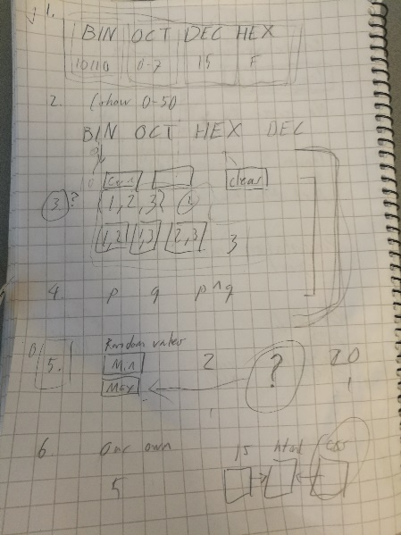 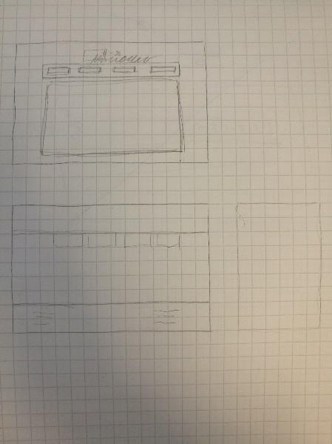

*Figure1.* The idée for all the layout of the website *(1)*

*Figure2.* A sketch of the different mathematic functions *(2)*

## Testing after implementing

We tested each function while and after implementing. If we found bugs, we fixed those bugs (and sometimes broke something else while fixing the bug). By testing all the different functions by inputting numbers, letters and pressing the buttons several times, we could find a few issues in number converter, combinatorics, truth table and the random value function.

The computer didn’t recognize backspace nor an empty field in the hexadecimal input, so when the user was removing characters from the hexadecimal input, it would give the user the same reminder when inputting non-hexadecimal characters.

Buttons had wrong names and that resolved in the buttons being not responsive. We accidentally had chosen a taken name for a button and changing that fixed the button.

Truth Table displayed the wrong numbers because of missing parts in the JavaScript code.

The repetition of the random number generator continued displaying more and more numbers even if it only should display 1-5. The solution for that was finding a stop for the loop and not displaying a number after the number 5.

In the beginning of the day were testing all the functions of the website and looked for bugs or anything that could be wrong. We went through the same process at the end of every day.

POSSIBILITIES OF FURTHER DEVELOPMENT

The web page could be developed further by adding more features to the current functions. This can be achieved by just adding more adding functions that can make the learning easier and to also use the option of a short explanation video for the different mathematic problems. Maybe also a function that gives the users the opportunity to interact with other people all over the world for exchanging questions and solutions.

Providing more detailed information about all these different mathematic disciplines. This could be achieved by making it work like an encyclopedia or an ordinary mathematic school book so that this web page can make it easier and faster for students, teachers or private users to reach this information.

A forum or a chat function could provide us with good information from the user. As developer this can benefit the future of this program by gathering information from the users: what's missing and how to make the site better. Showing this could also give the user some credibility towards the website. With further development this project can lead to cooperation with companies and schools.

conclusion

Through this project we have encountered a lot of challenges, mostly from the JavaScript coding for those different tasks and making the functions work correctly. The biggest issue or most challenging has been get a clean and understandable JavaScript code. The mathematic tasks have also pushed our minds because we had to transform many disciplines into functional code.

Knowledge and skill differences in class created some extra difficulties, but of course sometimes it helps. In a learning process it creates a lot of pressure because others know everything already and you are just standing there like “what?”. In this case it can simulate the working life and it´s something that happens every day.

Styling the website to make it more appealing for the user has been the easier part of the project. It was easy to choose the main color and create the layout. The color should be calm and not distract the user. By making the layout very clear and simple, gives it a more modern feel.

We took a small risk by building our project in different GitHub branches, because we didn’t remember much about merging branches. When we got to the point that we should merge, we were a bit worried about the results. We even made some temporary branches for backups. Luckily everything went really well, we only had to fix only a few problems in the code and everything was fine: we have a working website with every needed function.

REFERENCES

Picture taken from notebook, *figure* (1)

Picture taken from notebook, *figure* (2)

Attachment

Excel file:

[Time Tracking Sheet](https://oamk-my.sharepoint.com/:x:/r/personal/t7aljo00_students_oamk_fi/_layouts/15/Doc.aspx?sourcedoc=%7B799ccdd5-4a29-4217-9242-25daae45683f%7D&action=default&uid=%7B799CCDD5-4A29-4217-9242-25DAAE45683F%7D&ListItemId=60&ListId=%7BD6F6DFEA-E080-406E-819A-FA03596FC9EE%7D&odsp=1&env=prod)